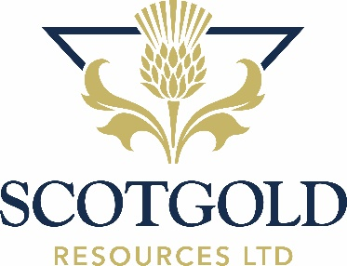
7 April 2022

Scotgold Resources Limited ("Scotgold" or the "Company")
Debt Funding Procurement Agreement

Scotgold Resources Limited (AIM: SGZ), announces that it has entered into an agreement with Fern Wealth GmbH to arrange the procurement of loan funding from a syndicate of high net worth investors for an amount up to £3 million (the "New Loans"). Fern Wealth is a sophisticated wealth management company based in Zug, Switzerland whose focus is to seek out and manage quality investment opportunities for their Investors.
Subject to the successful procurement of the New Loans, the Company intends to use the proceeds received to fast-track the Company’s Optimisation Initiatives to achieve a gold production run rate of c.23,500oz p.a. by the end of Q1 2023. Further announcements will be made in due course.
The core Optimisation Initiatives planned for 2022 include:
- Design, construct, and commission a tailings thickener, a cost-effective technology to improve the throughput and recoveries of concentrate product in the processing plant to achieve a monthly run rate of c. 4,000 feed tonnes to the process plant by end of Q2 2022 which equates to c 16,000 – 17,500 ounces p.a. run rate of gold by the end of Q2 2022.
- Enhancing mining efficiencies of the underground mine to ensure continuous operations; and
- Design, construct, and commission an ore sorter at the processing plant between the existing crushing unit and the Mill to realise an increase in ounces of gold processed per tonne at lower tonnages and potentially lower CAPEX and OPEX. Due diligence to be completed by the end of Q2 2022 and the sorter, if approved, to be operational by the end of Q1 2023.
The information contained within this Announcement is deemed by the Company to constitute inside information as stipulated under Article 7 of the Market Abuse Regulation (EU) No. 596/2014 (as amended) as it forms part of the domestic law of the United Kingdom by virtue of the European Union (Withdrawal) Act 2018 (as amended). Upon the publication of this Announcement via the Regulatory Information Service, this inside information is now considered to be in the public domain.
**ENDS**

Scotgold Resources Limited  Chief Executive Officer  Philip Day | SP Angel Corporate Finance LLP  Nomad and Broker  Ewan Leggat / Charlie Bouverat | Celicourt Communications  Financial PR  Felicity Winkles
 | Tel +44 (0) 20 3470 0470 | Tel +44 (0) 208 434 2643  Tel +44 (0) 774 8843 871

Notes

Scotgold Resources Ltd (AIM:SGZ), is Scotland’s first commercial gold producer. The Company poured first gold in November 2020 at its Cononish Gold and Silver Mine (‘Cononish) in Tyndrum, Scotland and is developing it into a +23,500-ounce gold mine per annum by end of Q1 2023. Cononish is a high-grade underground mining operation with a central processing plant producing gold concentrate for off-take and gold doré for the Scottish Jewellery industry. Once in full production, the mine has anticipated forecast operating costs of c.£544/oz AISC, which will place Cononish in the lowest quartile of gold mining operations globally.

It is Scotgold’s vision to build a mid-tier gold mining company in Scotland with multiple operations in the country that enhance the local environment and economy in ways that have an enduring positive impact.

