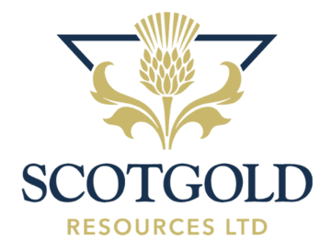

29 December 2022

Scotgold Resources Limited ("Scotgold" or the "Company")
Notice of AGM

Scotgold Resources Limited (AIM: SGZ), Scotland's first commercial gold producer, announces that its Annual General Meeting ('AGM') will be held at 9:00am GMT on 19 January 2023.

The Company will hold a shareholder webinar during the AGM for shareholders to listen to the business of the meeting and participate in a question and answers session.
To attend the AGM, investors can sign up to Investor Meet Company for free and add "Scotgold Resources” via the following link to join the webinar:

https://www.investormeetcompany.com/scotgold-resources-limited/register-investor
The Company's Notice of AGM and Forms of Proxy will be dispatched to shareholders later today and together with the Annual Report and Accounts will be available on the Company's website at www.scotgoldresources.com .

**ENDS**

Scotgold Resources Limited  Chief Executive Officer  Phil Day  Via Celicourt Communications | Shore Capital  Nomad and Broker  Toby Gibbs / John More  Tel +44 (0)20 7408 4090 | Celicourt Communications  Financial PR  Felicity Winkles  Tel +44 (0) 208 434 2643  Tel +44 (0) 774 8843 871

Notes
Scotgold Resources Ltd (AIM: SGZ), is Scotland's and the UK's first commercial gold producer. The Company poured first gold in November 2020 at its Cononish Gold and Silver Mine ('Cononish') in Tyndrum, Scotland and is developing it into a +23,500-ounce gold mine per annum in 2023. Cononish is a high-grade underground mining operation with a central processing plant producing gold concentrate for off-take and gold doré for the Scottish Jewellery industry. Once in full production, the mine has anticipated forecast operating costs of c.£544/oz AISC, which will place Cononish in the lowest quartile of gold mining operations globally.

It is Scotgold's vision to build a mid-tier gold mining company in Scotland with multiple operations in the country that enhance the local environment and economy in ways that have an enduring positive impact.

